How to create a word template
This guide will take you through how to create a branded word template, including custom typography styles, a header and footer, page numbers. First, we’ll look at a basic letterhead template, then go through some easy steps to take your template to the next level with a cover, for use in reports or submissions.

Customising the default styles to apply brand fonts
Creating a branded header / footer
[Optional] Adding custom artwork as a page background
Creating a second “Cover Page” version of your template

Customising the default styles to apply brand fonts
Default fonts and headings in your documents might be a giveaway that your just using the default Word template! The following steps will allow you to change these defaults to your own brand fonts, and send documents that are more professional and more consistent with your website and other materials.

Start by opening up a new doc in Word.

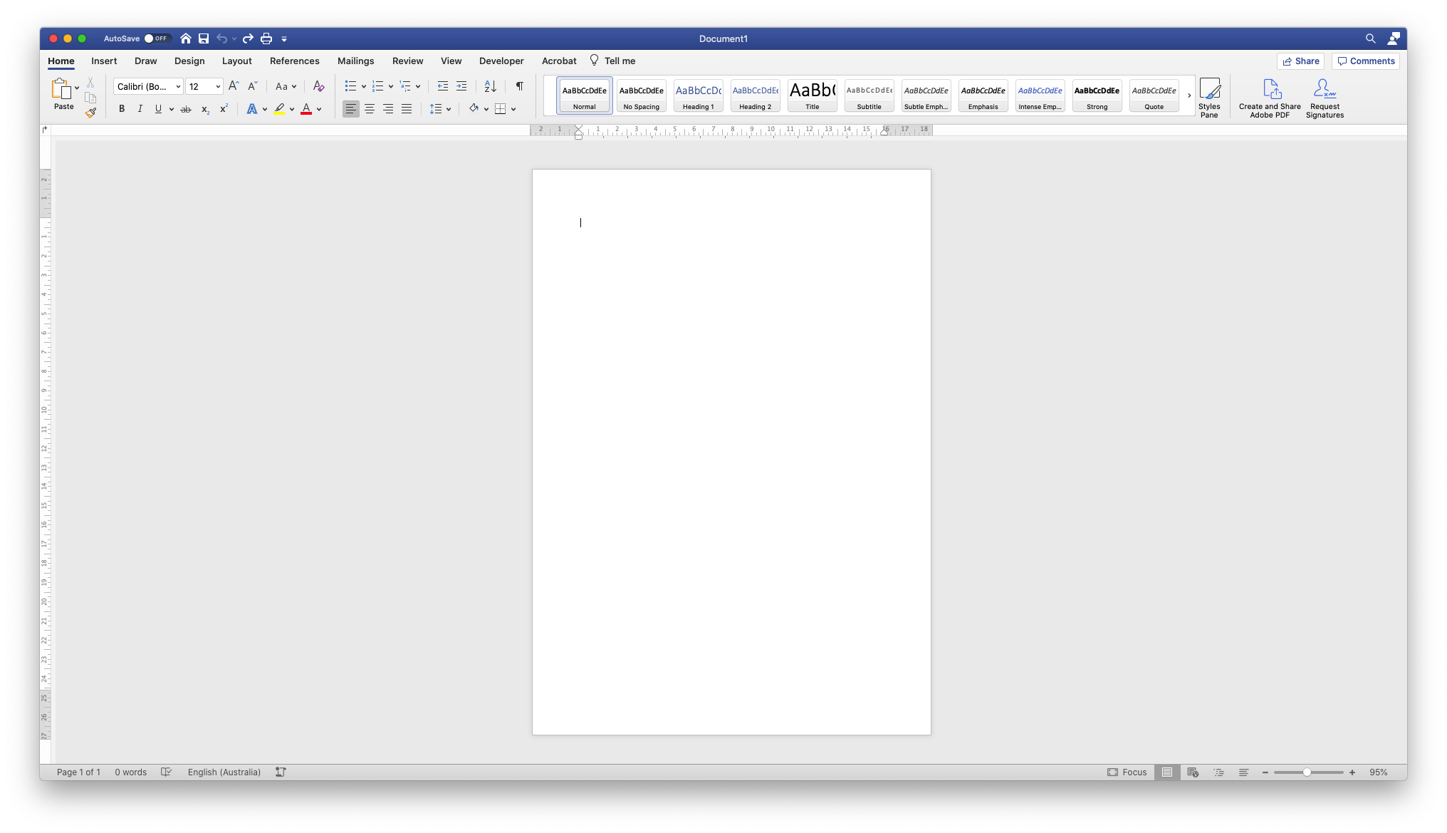
Our first step is to customise the default styles for Headings and Body text, replacing the default fonts with our brand fonts.

Note! If you require sending this Word template to other users (as a .docx), it’s best to stick to system fonts (not fonts downloaded from the web). This will ensure your documents always appear consistently, and the user on the other end isn’t missing the required fonts in the document.

If you’re just saving to PDF and sending, other fonts are fine. These fonts will be embedded in the PDF, and will appear the same no matter where they’re viewed.

Copy and paste the following text into your blank Word doc, so that we have an example of each style we want to customise on the page:

Title
Subtitle
Heading 1
Heading 2
Heading 3
Heading 4
Normal

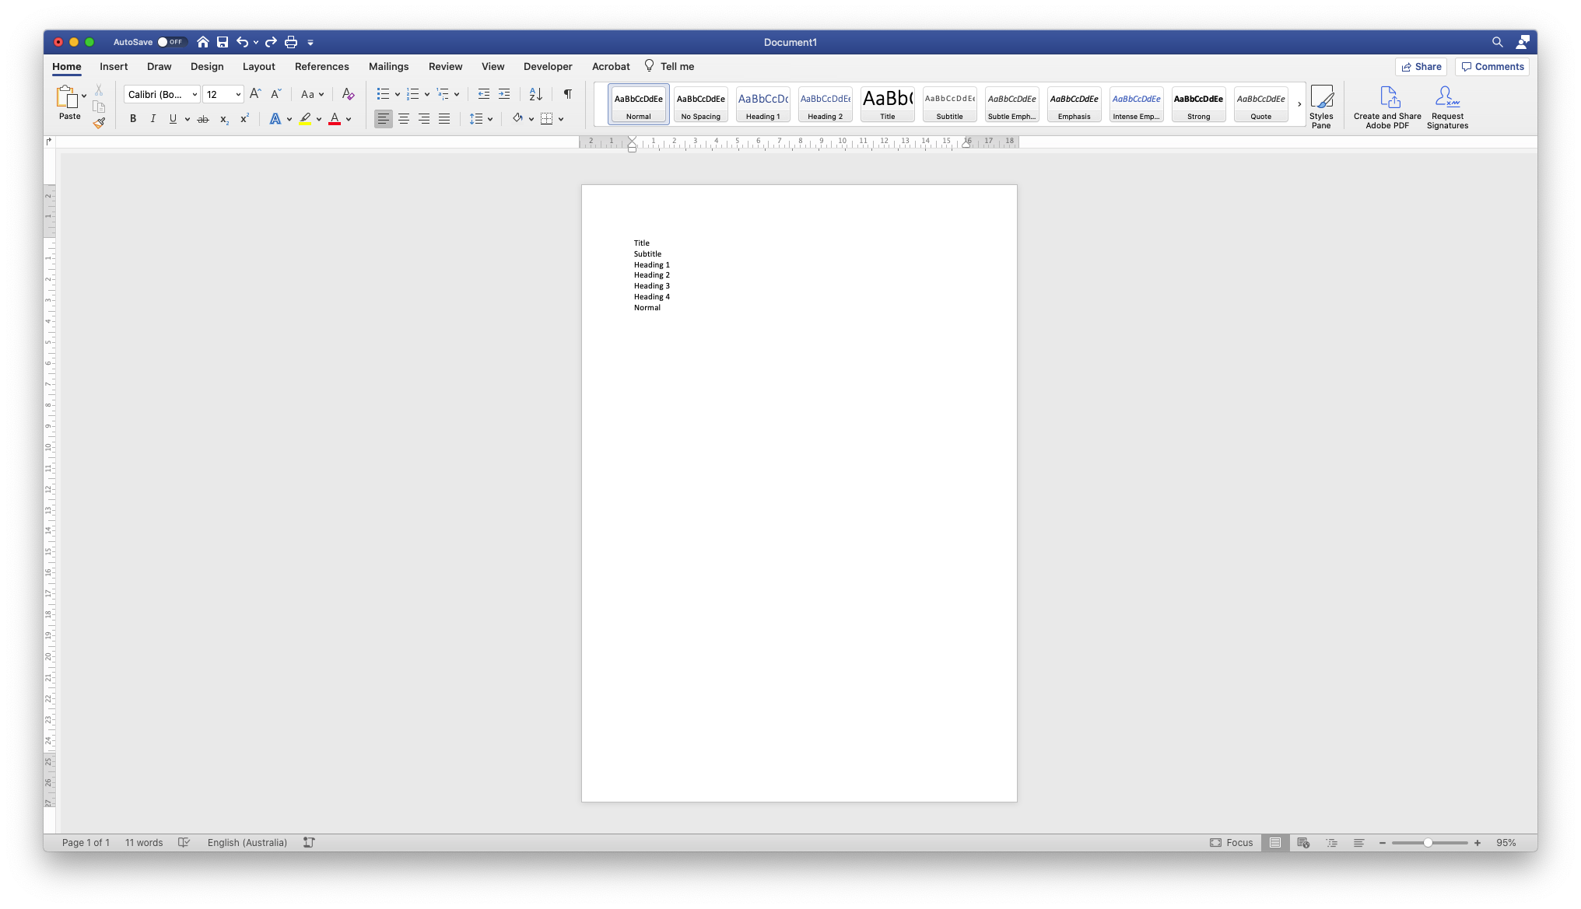

Open the Styles Pane in the top right to show existing styles in the doc:
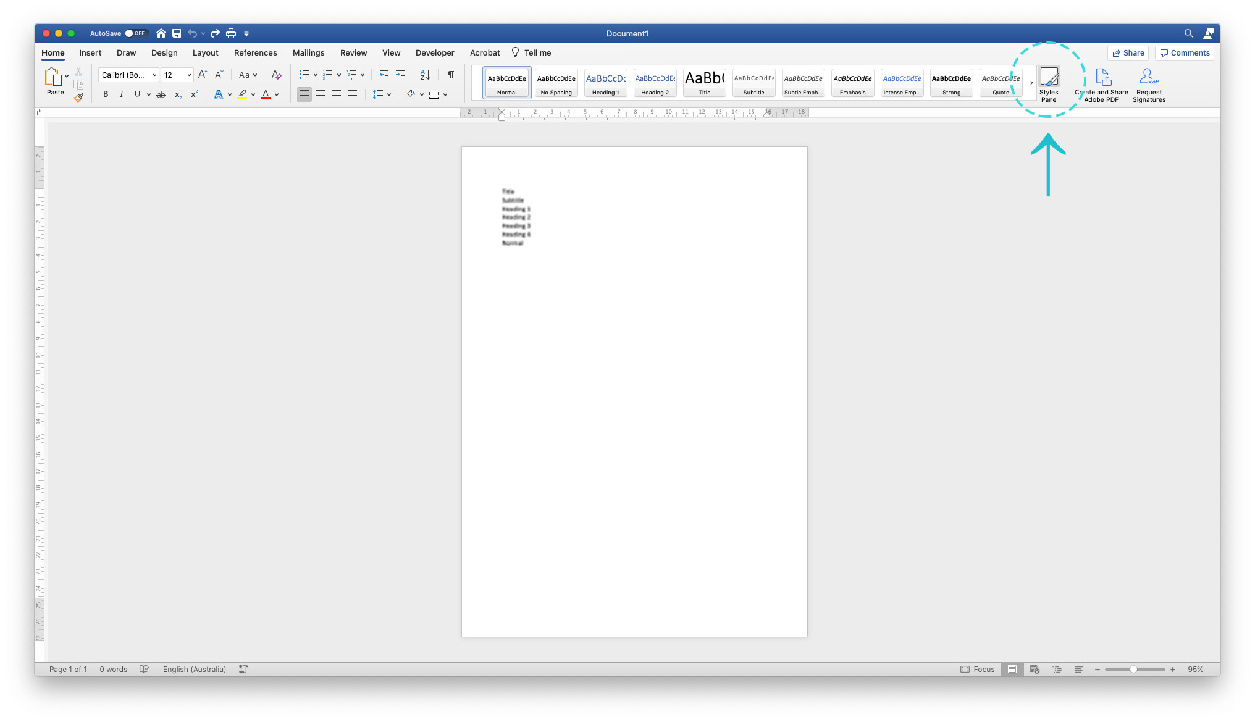

One at a time, select each heading on your page, and click the corresponding style in the Styles Pane to apply that style.

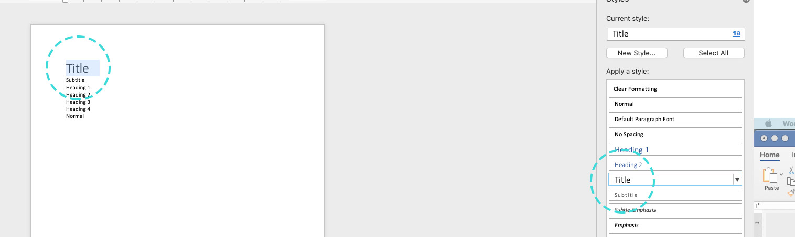

Your page should look like this when complete:

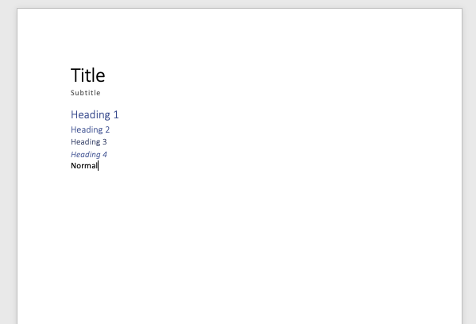

Now, we can apply our brand fonts to the styles on the page. Hopefully you might have a brand style guide to consult for your brand fonts (or the system font substitute if needing to send this as a .docx file - see note above for more detail).

Some brands will have a different font specified for headings and Normal body text – or you might just have one font used for all.

Select all the document styles, and change the font to your choice:

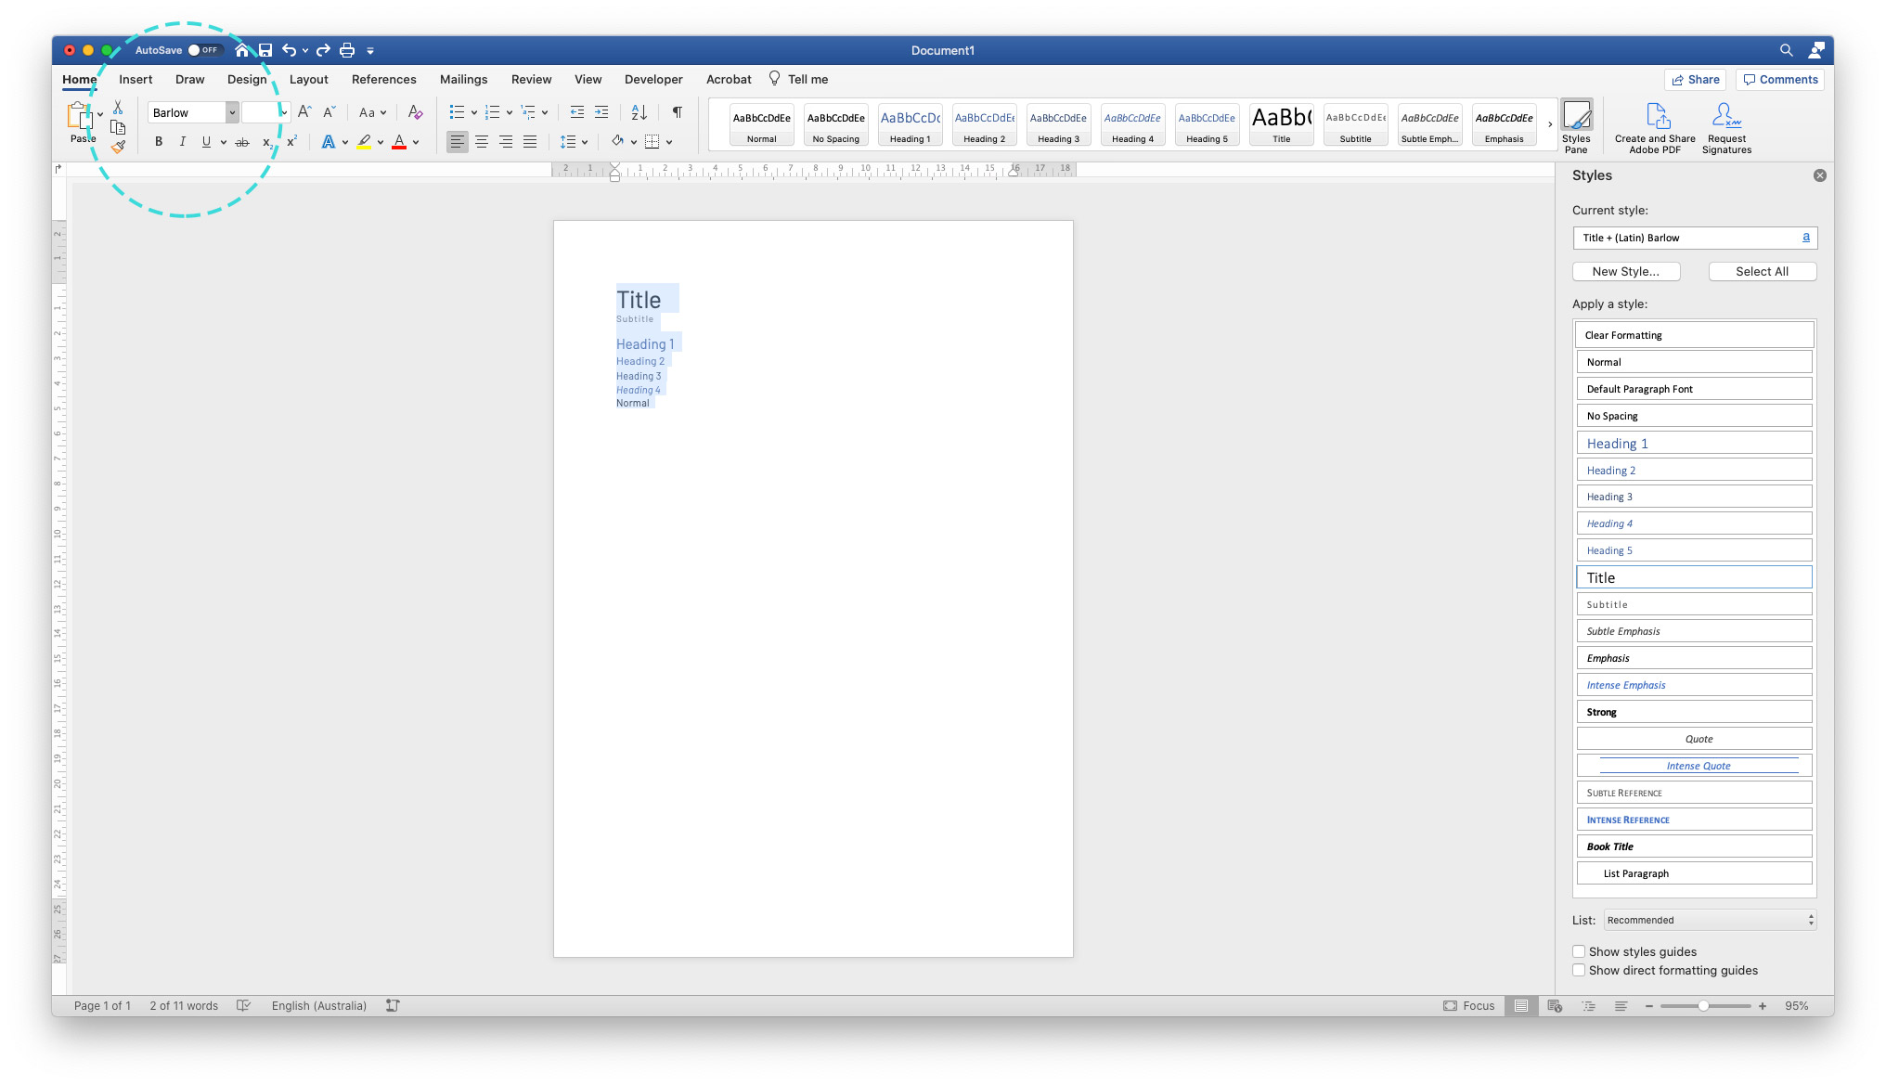

In our example, we’re using Barlow – a nice serif from Google Fonts that I’ve installed on my machine. On the other hand – the custom template this document was made in uses Calibri and Avenir, as they’re system fonts and will always appear consistently across different machines.

Now, you can just leave it here and skip to the next step – but it’s worth spending a little time here customising your font weights, colours, and sizes, to make your document a little more branded and distinctive.

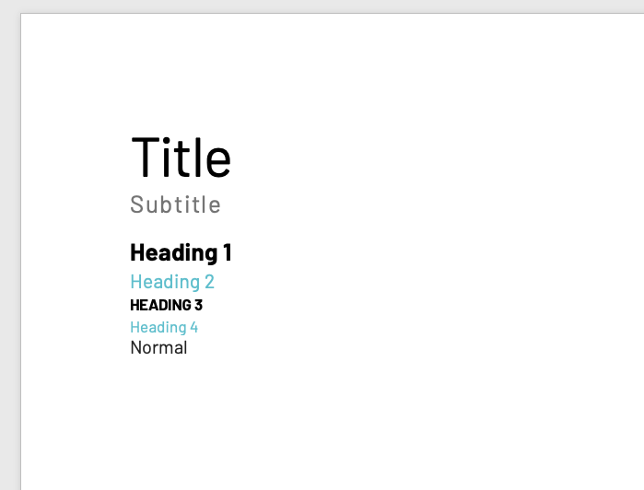
There are no wrong answers here – but I’ve made some quick edits to increase the contrast between the different heading hierarchies – some bigger and bolder, others smaller and lighter – which will assist users in navigating the documents you send out.

Once happy, you can select each style once more, and use the dropdown menu on the right to Update to Match Selection:

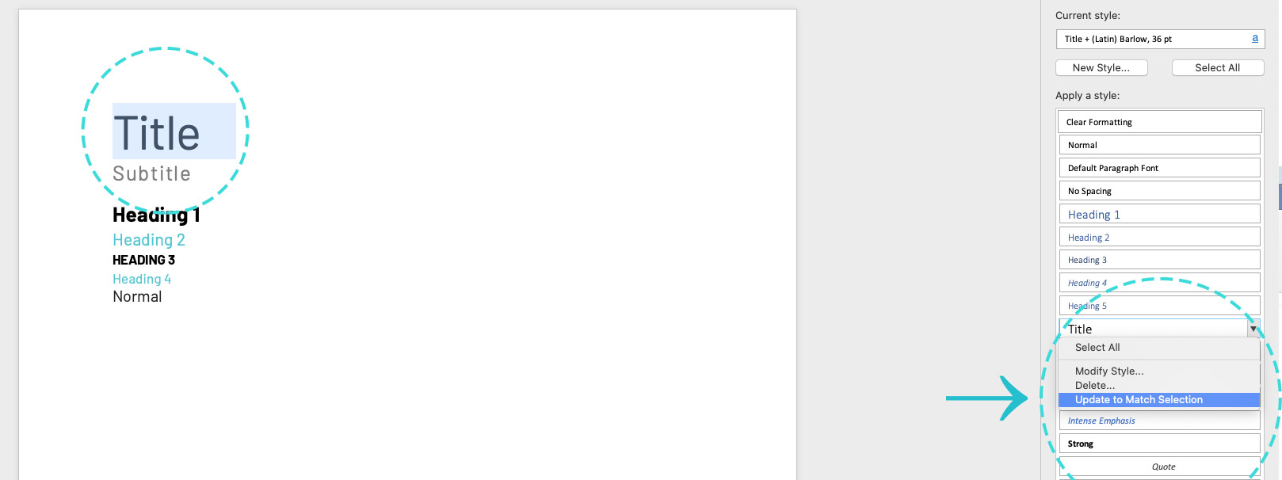

This commits those style changes to the document, ensuring users have these defaults on hand without having to customise each document as they go.

Creating a branded header / footer
Best to save your Word doc now if you hadn’t already!

Next we’ll add a logo to the header, and a neat footer with a page number that will recur on all pages.

To “open” the header and footer for editing, double click anywhere in the header area at the top margin of the page.
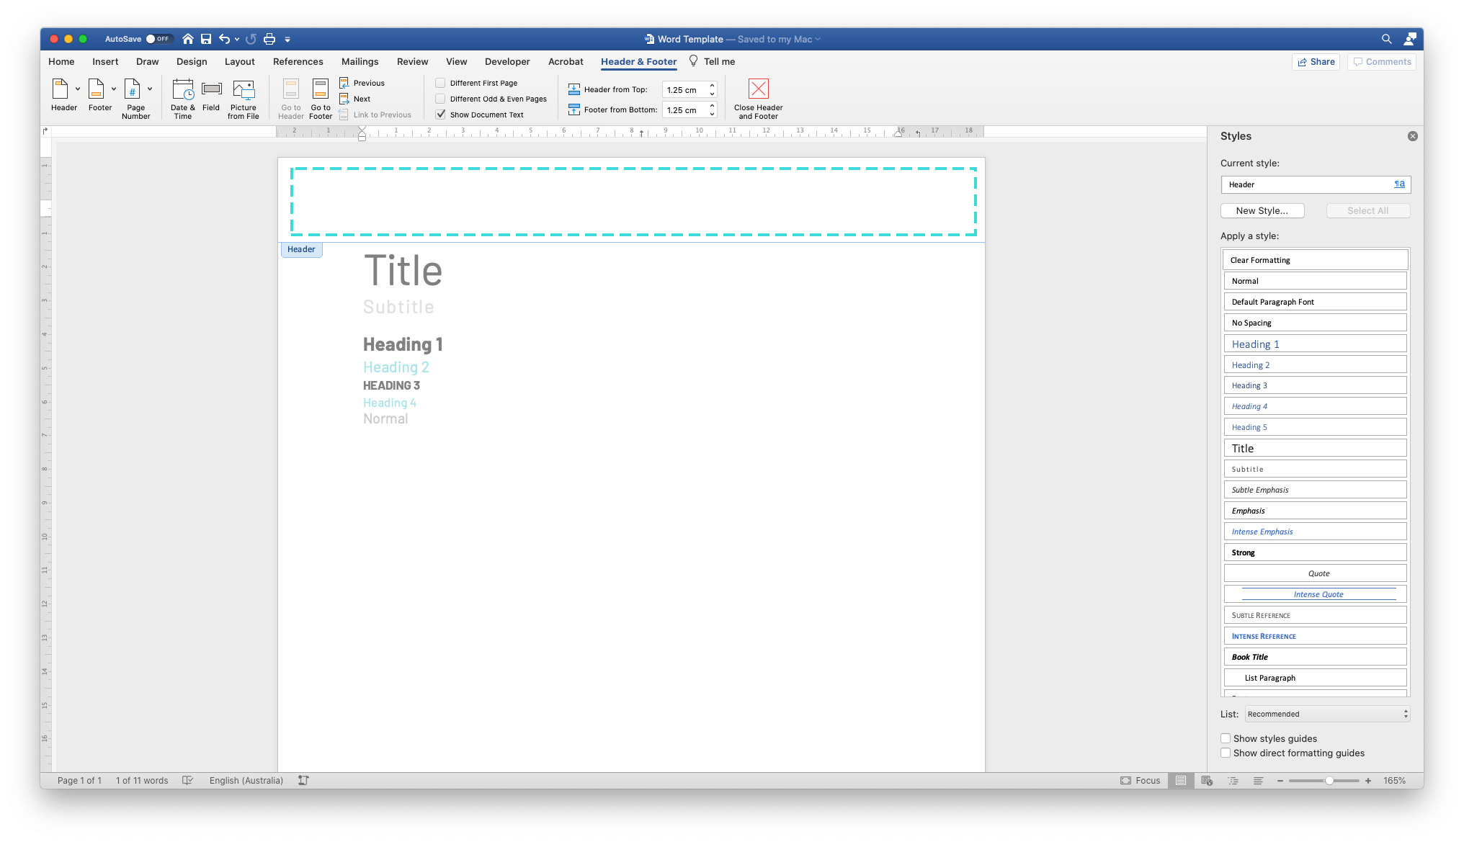

Here, we could add contact details, a website URL – really anything that you might put on a business card is open fodder for branded templates. It makes the document feel like it’s a representative from your business, just like your shopfront or website would be.

For this example, we’ll just add a neat logo in the top right of the page.

Drag and drop your logo (either a PNG or JPG) into your header area.

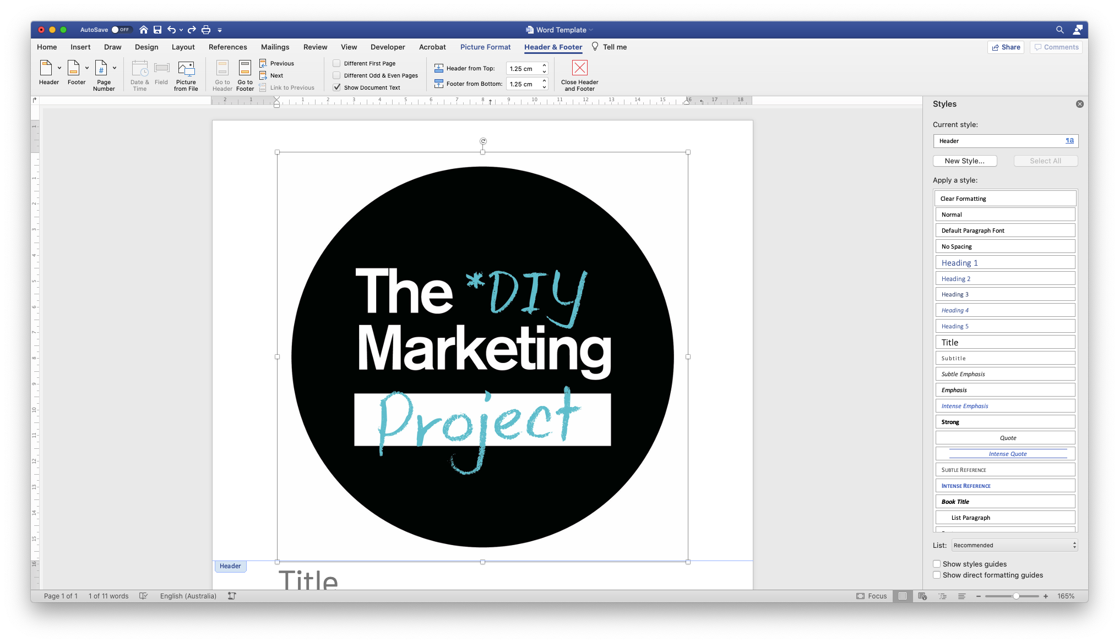

Your text may move if it’s a high-res logo – remedy this by resizing the logo, and setting your text wrap to “Behind text” (Under Picture Format tab > Wrap text). This will mean it won’t interact or push the document text around no matter where it’s positioned on the page.

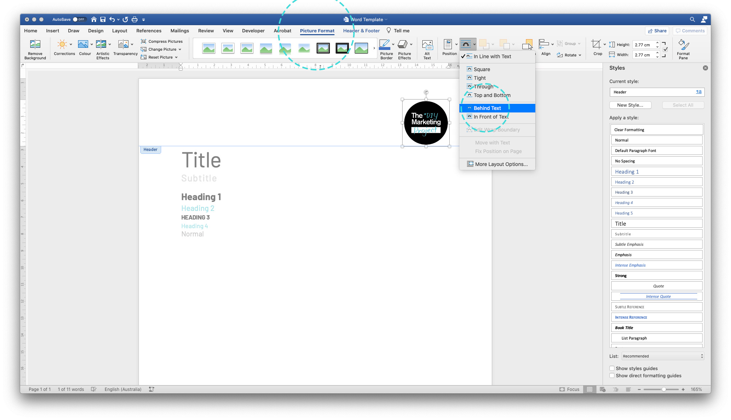

Now, we’ll double-click on the footer area to add some text there.

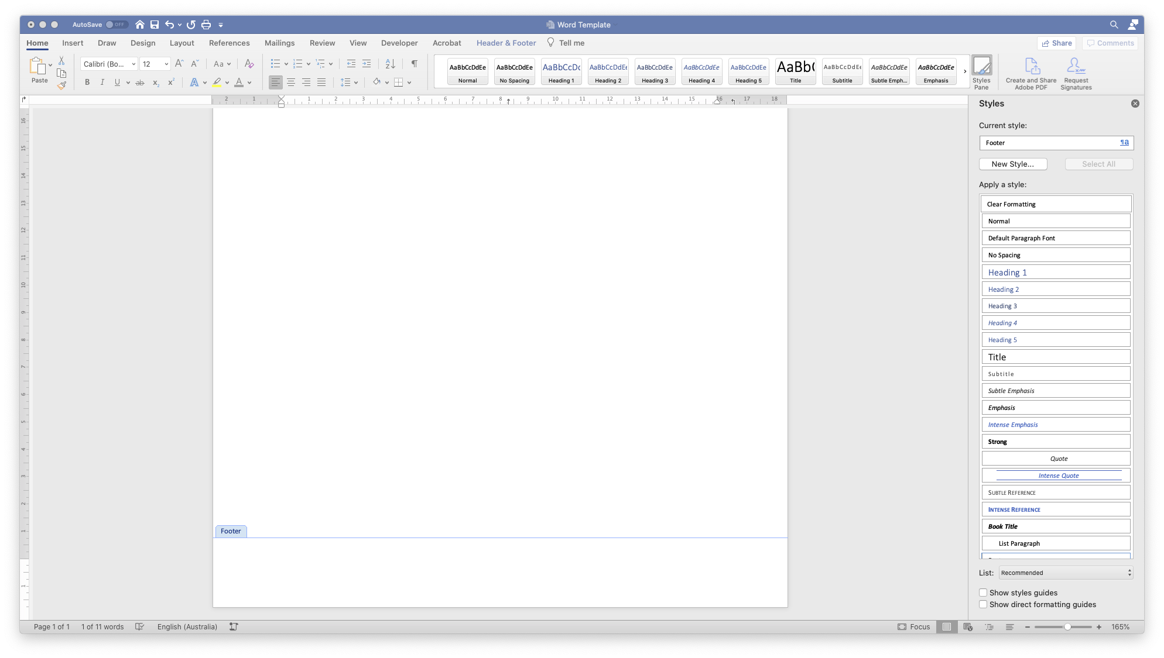

Here I’ve added some details to appear on the bottom of every page – the document name, who the document is for, and a date.

This isn’t prescriptive – you could also add contact details here, a tagline, or nothing if a minimal document style is more suitable. Remember anything in the header or footer will appear on all pages, so too much information may distract the reader from the actual document content.
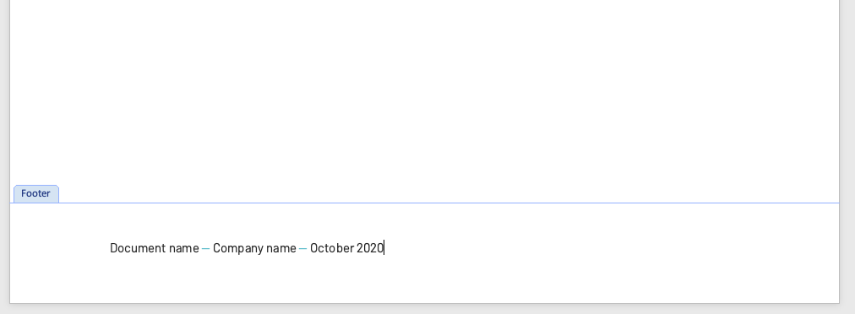

To add a little extra brand colour, and to separate these footer elements from the document text, I’ve chosen to add a line (under Insert tab > Shapes).

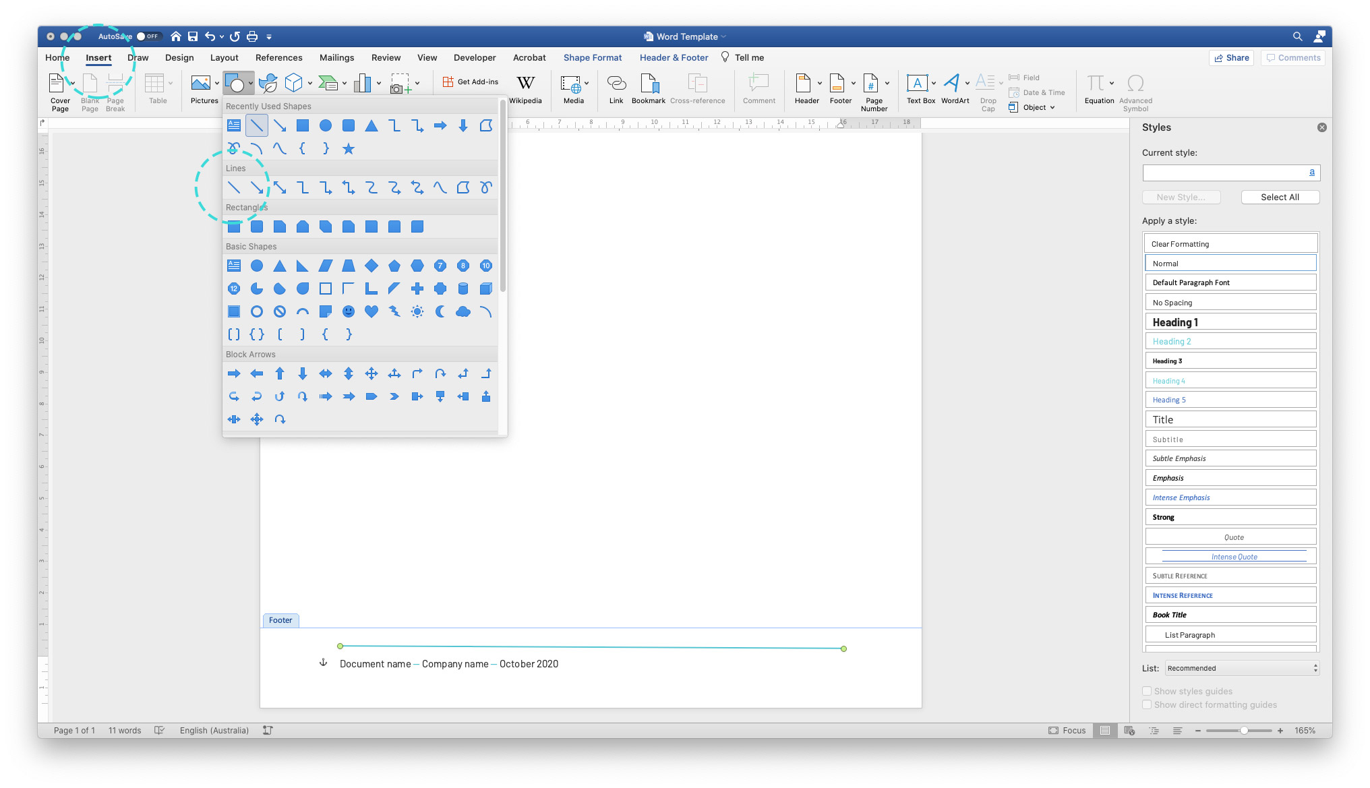

I’ve just sized it to the width of the margins, increased the weight, and changed the colour to TMP Teal.

Next, we’ll add a page number. Go to Insert on the top menu, then Page Numbers.
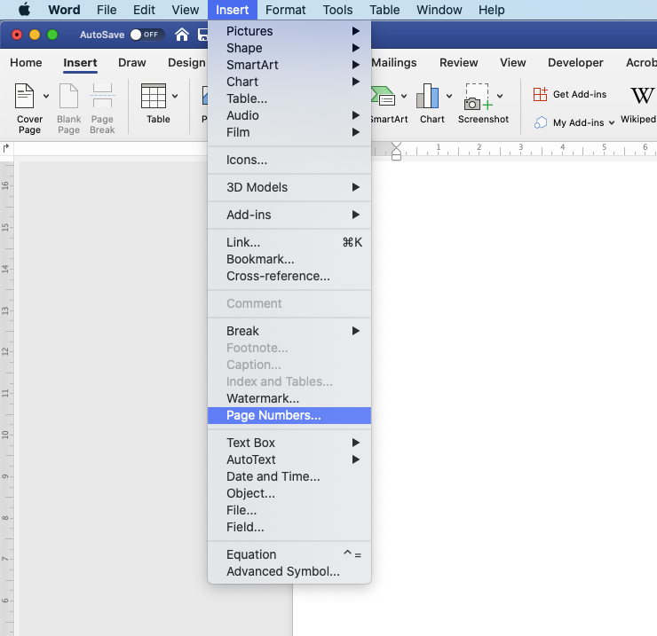

The defaults are fine in the window that appears:

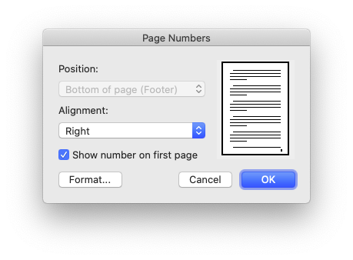
This will add a tiny text box with the page number in your Footer.

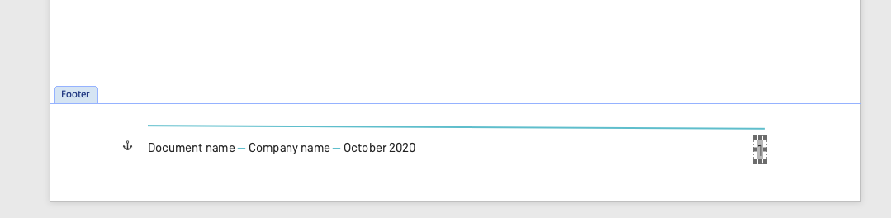

You can click and resize this box, edit the font and sizing to match your other text, and even add “Page ” ahead of it (the number will update dynamically across pages.

It’s best to right-align this number so it always hugs the right margin, and allow some extra room on the left if your document is going into large page numbers – Page 103 for example — this will ensure the text doesn’t push over two lines in this box.

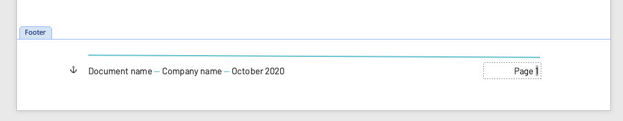

And that’s done! You now have a branded template you can use for any letter or document, which you could distribute to staff for consistent, company-wide comms.

[Optional] Adding custom artwork as a page background
If you’d like to take your templates to another level and have access to design software (e.g. InDesign or Canva), you can add some more branded flair with an image-based footer, achieving formatting that might be a bit tricky to create in Word alone.

This will be achieved by exporting a background image with branding, and adding it to the footer of your document.

Open up your design program of choice and create a branded A4 layout to appear as a static image on all pages. Page numbers or other editable text will need to be added separately in the doc – leave spaces in this “image” if necessary.

As an example, The Marketing Project’s word template background image looks like this in InDesign:
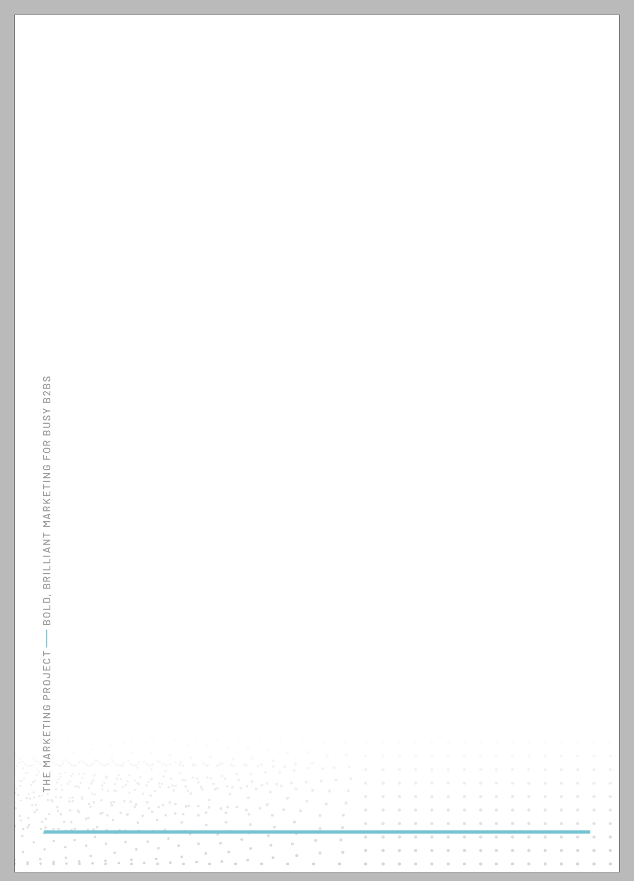

You’ll notice I’ve reserved some space in the bottom for the document details and page number. This image will give us a similar “footer line” to my above example, along with a subtle dot texture in the background, and some vertically-running text up the side with our Company name and tagline.

Once exported (use 144dpi resolution for web documents, 300dpi for print), this image can be placed in the footer of your document. Double-click to edit, then add your image to the doc:

Like with the logo before, we’ll need to make some Picture Format tab changes so it appears properly and doesn’t affect the other doc text. Set to Behind Text:

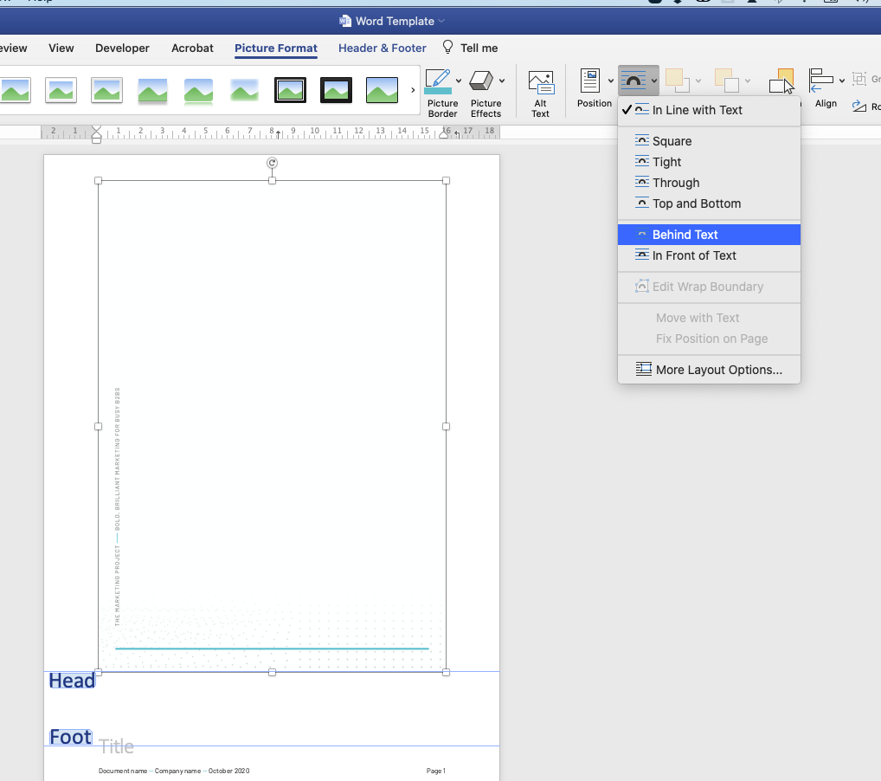
Set Width to 21cm so the image resizes to fill the A4 page size.

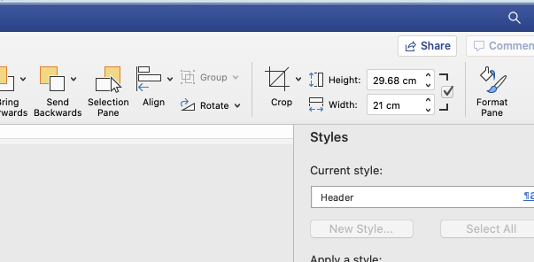

Align image to Center (horizontally and vertically) so that your image sits perfectly in position.

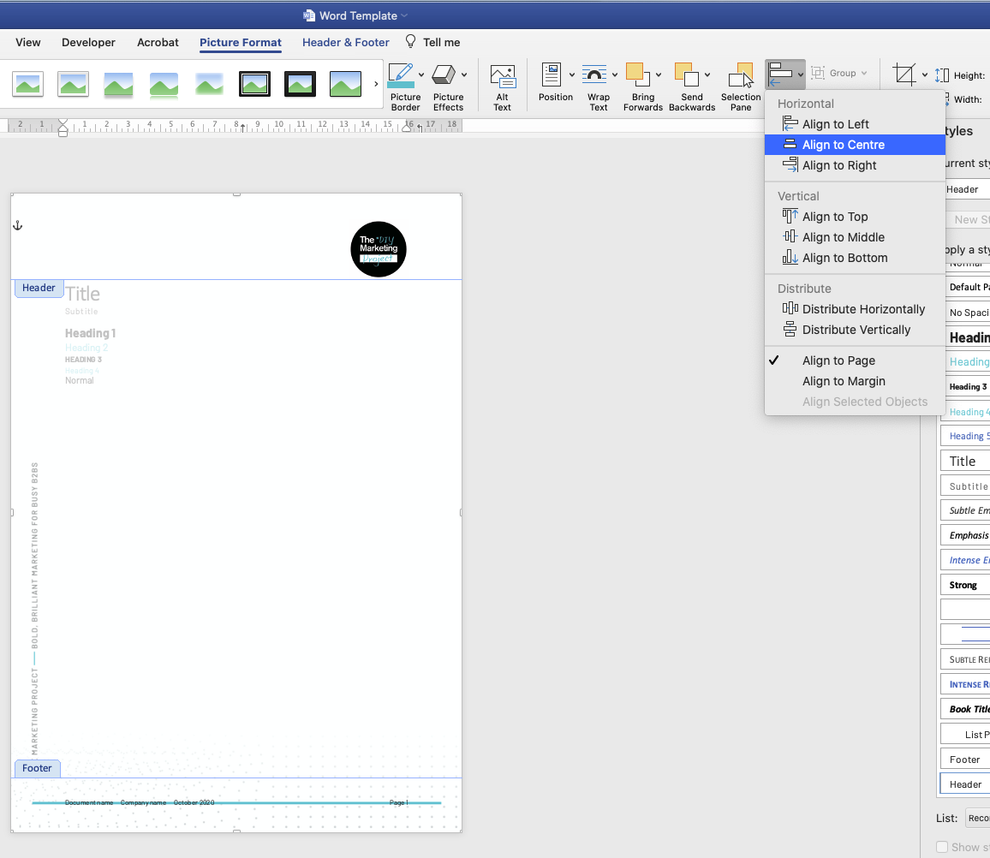

You may have to re-align your footer text to the page elements in the image – I had to adjust my bottom margin to shift my footer text below the line in my background image:

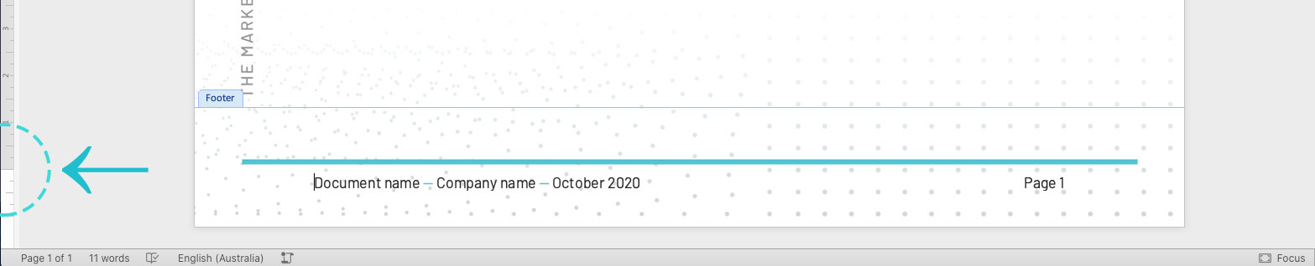

And Voila, a branded template ready to use! You’ll notice the Header and Footer elements appear “faded” when editing the document text – rest assured these will appear full-colour when exported as a PDF or printed.

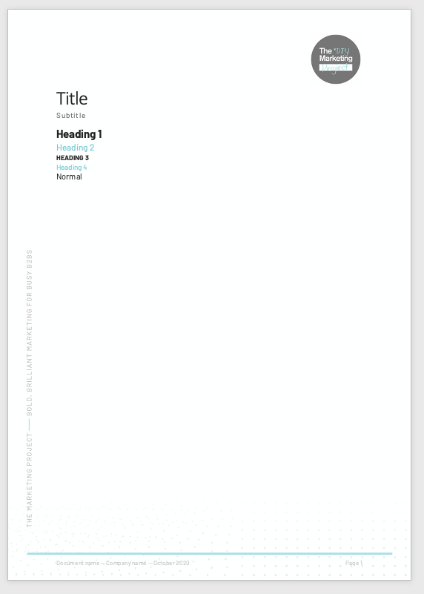
The last step is to Save your document as a .dot Word Template file. This will ensure users cannot overwrite it, they’ll need to Save-As each time they create a new doc.

Select .dot from the dropdown when saving, and Save your document template in a place where all staff can access it.

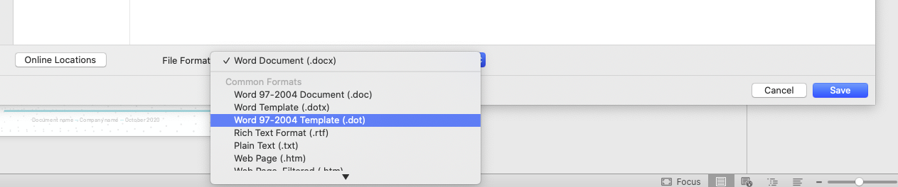

Creating a second “Cover Page” version of your template
Now that we have a document template with footer and all document styles set, we could adapt it to be used for a report that requires a cover. This will repeat the image-creation process above – just with a cover page instead of the internal page background.

First we’ll double click the top area to edit the header – then select “Different First Page” to allow us to add a different header “image” for our cover.

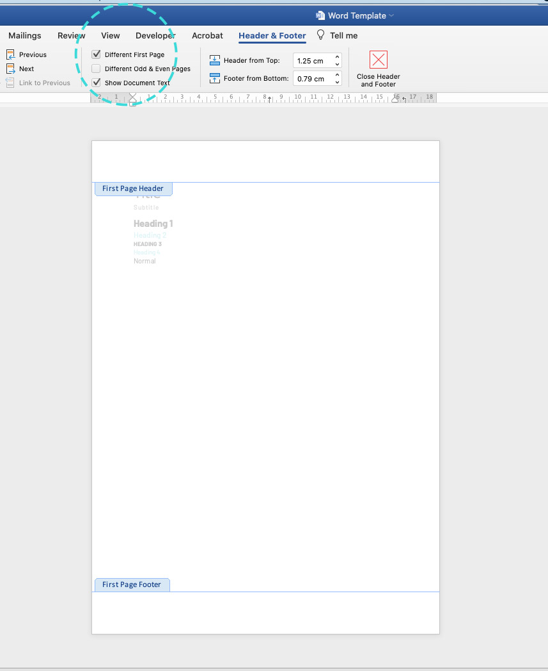

The header/footer content you just created will disappear! But don’t worry, it will appear again once you add a second page to the document. What you see at the moment is your “First page”.

Click the beginning of your document text, and use Command-Enter on Mac (or CTRL-Enter on Windows) to push your content to a new page. This will leave the First page blank.
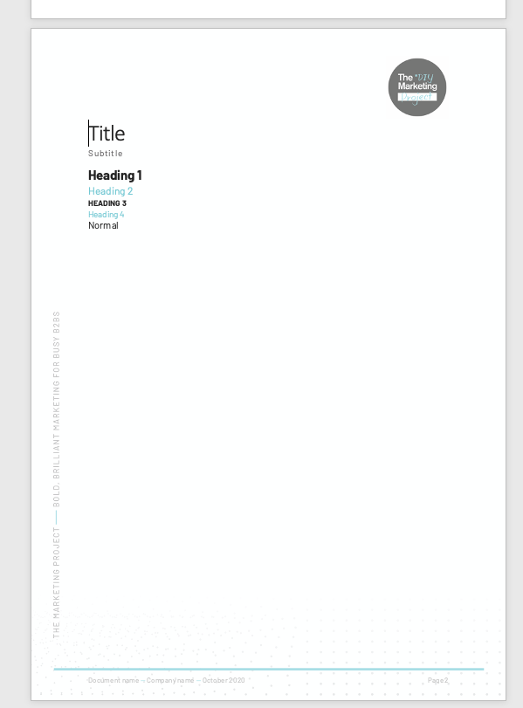

You’ll now have a clear space to add your first page. Design your cover however your link in your design program of choice. It is possible to add your cover text in Word and have it editable, but I find it’s easier to design this whole image at once, and add it as a single file to the first page’s header.

You’ll need to make the same adjustments upon placement as the footer background above – change to Behind text, scale image to A4 size, and align to center horizontally and vertically.

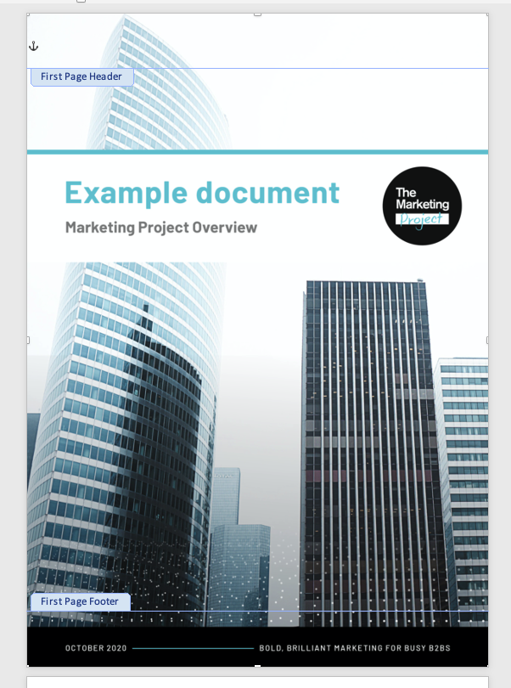

And done! You now have a cover for your Word template, and you can Save As this doc with the .dot format in the Save window so preserve it for future documents.

A new cover image will need to be inserted for each document – we use a standard base layout, but change the date, background image, and title text each time to suit the purpose.

We encourage you to experiment with different formats – minimal VS colour-rich designs – and see what suits best. Happy templating!

