Briefing Basics
If you’re using freelance copywriters, hiring permanent ones or just want to get your thoughts together, you’ll need to write a copy brief. Here, you package up all the required information about the job that a writer might need to know.

Alongside the brief, you’ll also want to provide a brand story and tone of voice - if you haven’t yet been through that process, grab our template and guide for creating your own brand story in the ‘marketing strategy’ department.

Who, What, Where, When and Why?

The framework for a brief can be simplified into ‘Who, What, Where, When and Why?’. This forms 5 distinct pillars and within each, more specific details can be addressed. The following pages are an opportunity for you to fill in the fields which will form the core of the brief.

The below diagram illustrates the 5 key questions and the rationale behind them.

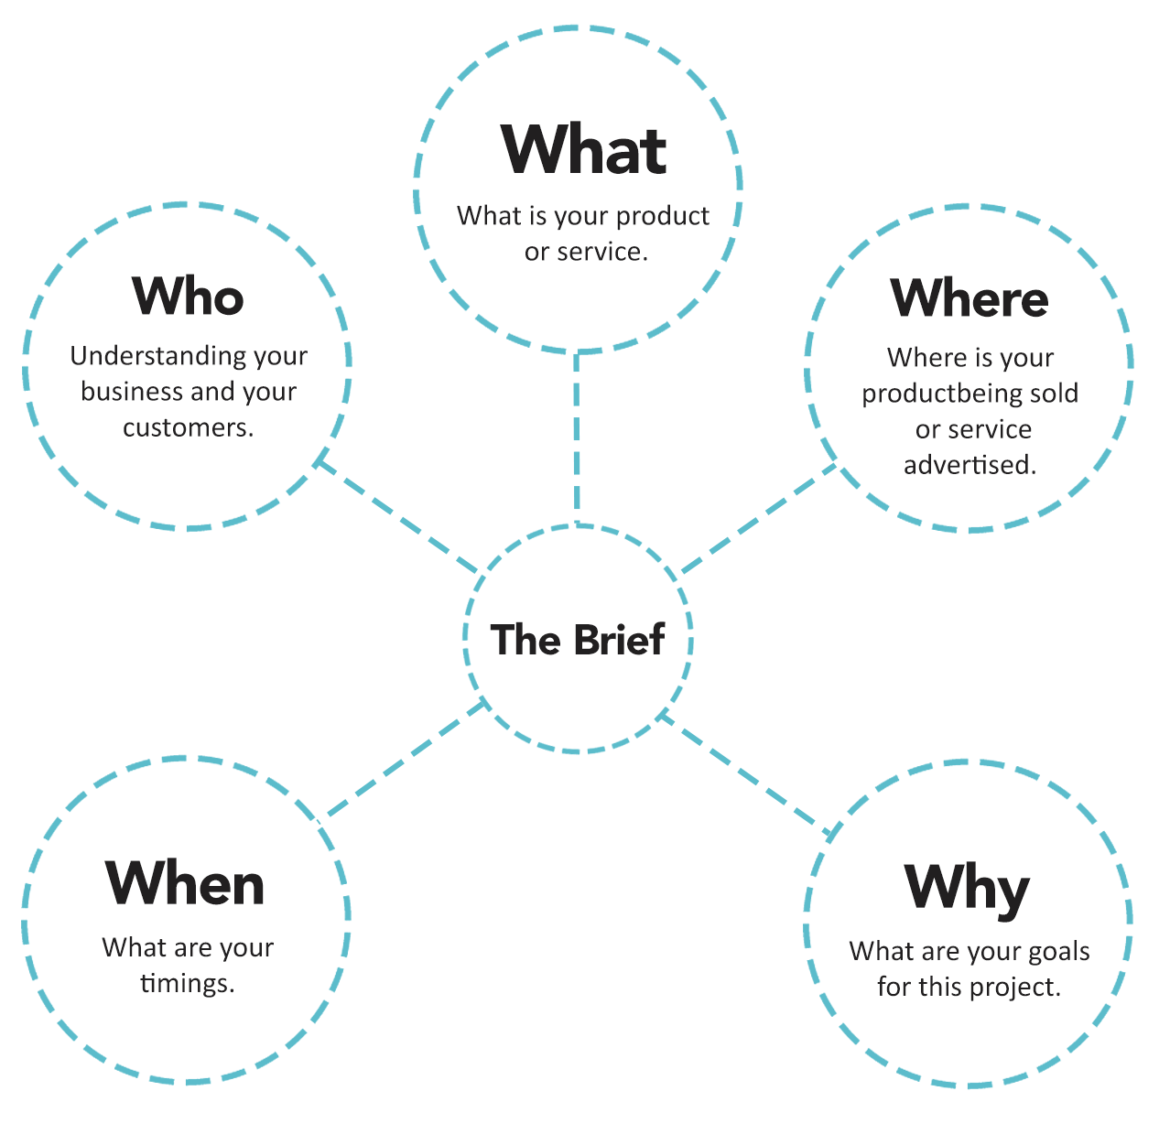



1a. WHO are you
Write about your business in the box below.

1b. WHO are your customers?
Who are your customers? Age, gender, etc can all help inform the message and tone-of-voice of the product / service positioning.

1c. WHO are your competitors?
This helps you differentiate from them.



2a. WHAT are you selling?
Is it a product, a service, or yourself?

2b. WHAT is the main selling point?
What makes this product / service unique? What are the features that you want to promote?

3c. WHAT assets are available?
Logos, images, etc.



3a. WHERE is this product / service sold?
Is it on a shelf, online? In a brand retail store or amongst competitors?

3b. WHERE does the product live post purchase?
Does it live in an office, at home, outside?



4a. WHEN is the project due?
Let us know you key deliverable dates (if applicable) ie;
- When are the deliverables due?
- When is the launch?
- When will this promotion finish (or how long will it be on shelves)?

Last updated February 2024

