Finding Content Collaborators on LinkedIn
The objective of looking for content collaborators is to find people to co-host webinars with you or work on larger content pieces (for mutual benefit) so you can both leverage off each other’s audiences. This means that there will need to be a cross over in your target audiences, so you can talk about the same topic, but you won’t be competitors.

Here’s how we find content collaborators on LinkedIn:

- Log in to your LinkedIn account
- Use the search bar at the top next to the LinkedIn logo and type in a hashtag that relates to your topic of interest (in our case it’s #b2bmarketing), then hit return.

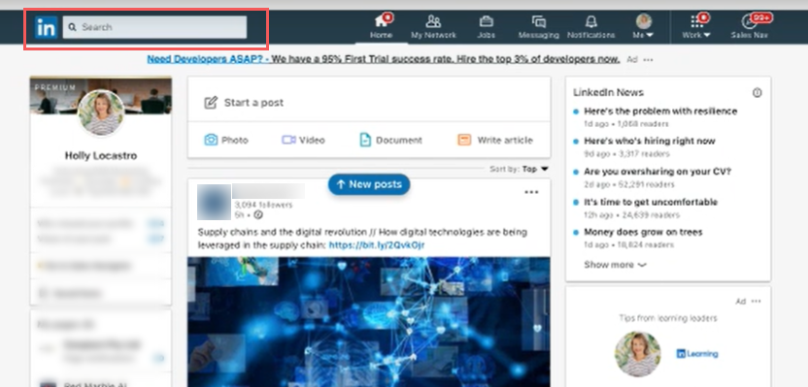

- Hint: once you start typing, it’ll give you some suggestions to look through as well.

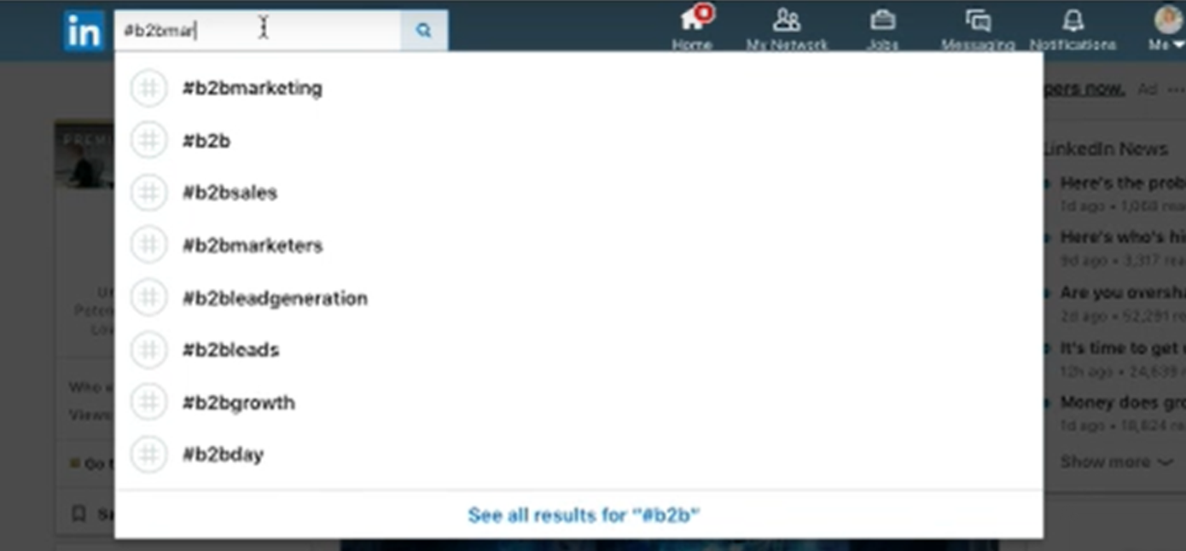

- You have a few options to filter your search results (you don’t have to filter your feed, but the option is there if you wish to use it)

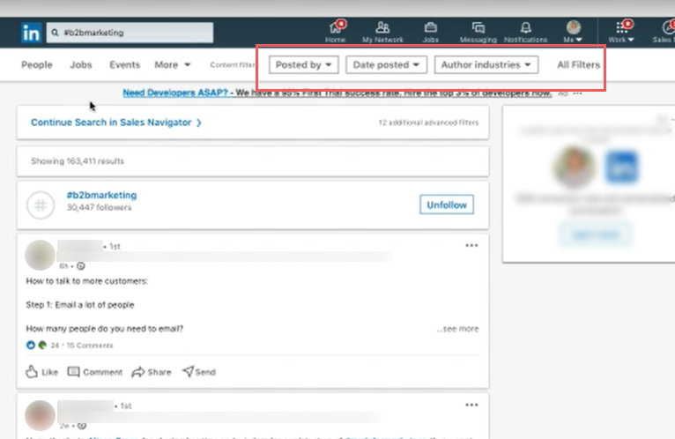

  - Posted by – you are more likely to get a better response rate from your 1st connections
  - Date posted – choose the most up to date if you wish
  - Author industries – select your industry or one that feeds into your audience

- Click on ‘All Filters’ to bring them up at the same time, making it easier to choose whatever combination you wish to use, and click apply.
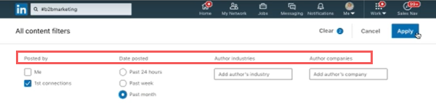

- You will then see a new feed that will bring up whatever you have filtered. In this case it is anyone using a #b2bmarketing hashtag in their posts, within the last month, and 1st connections (those that are closely connected to you).

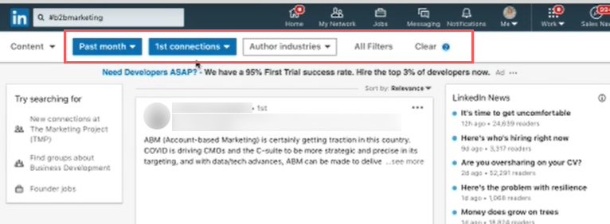
- Scroll through and read their content, look at their job titles and their company to assess compatibility with your content, audience and brand message.
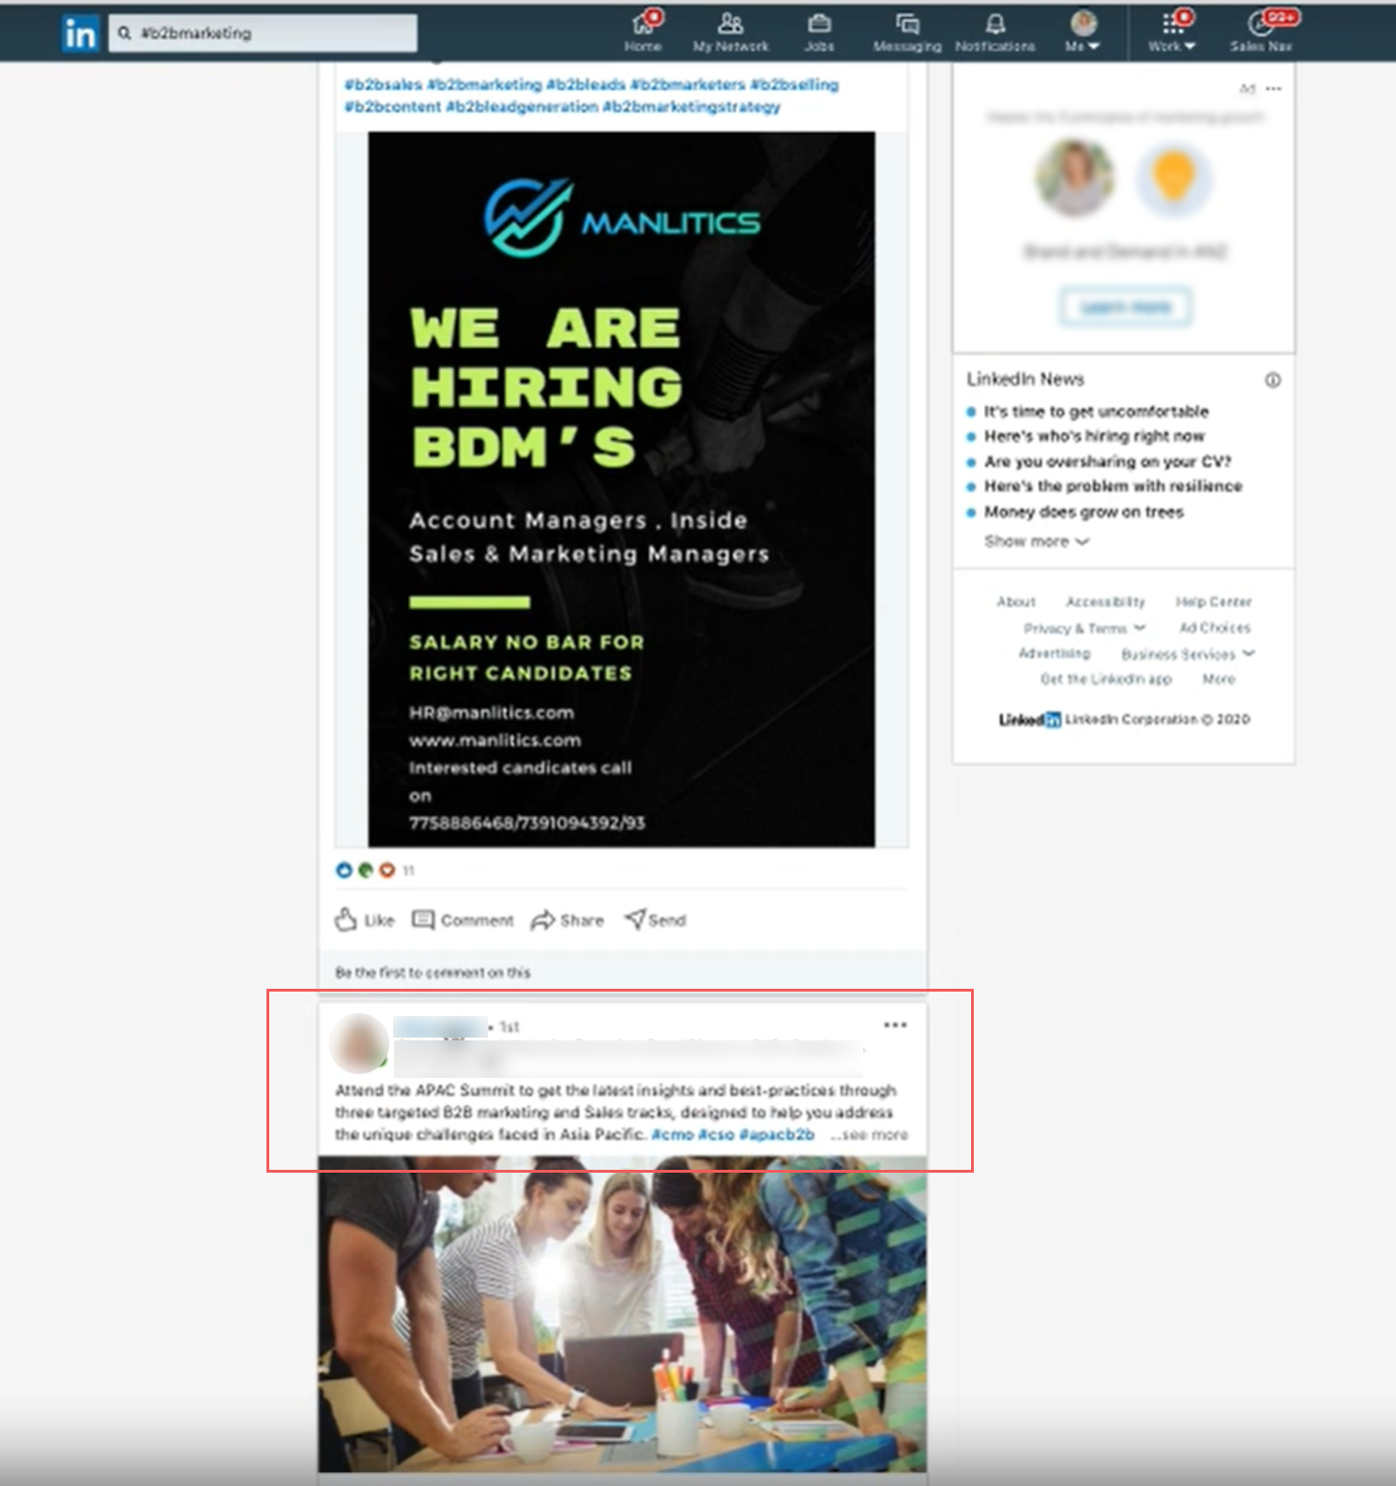

- When you find one that you think might meet your requirements, click on their profile and read through their company, what information they have available and check if their location is relevant if your audience is in a specific state, country or region.

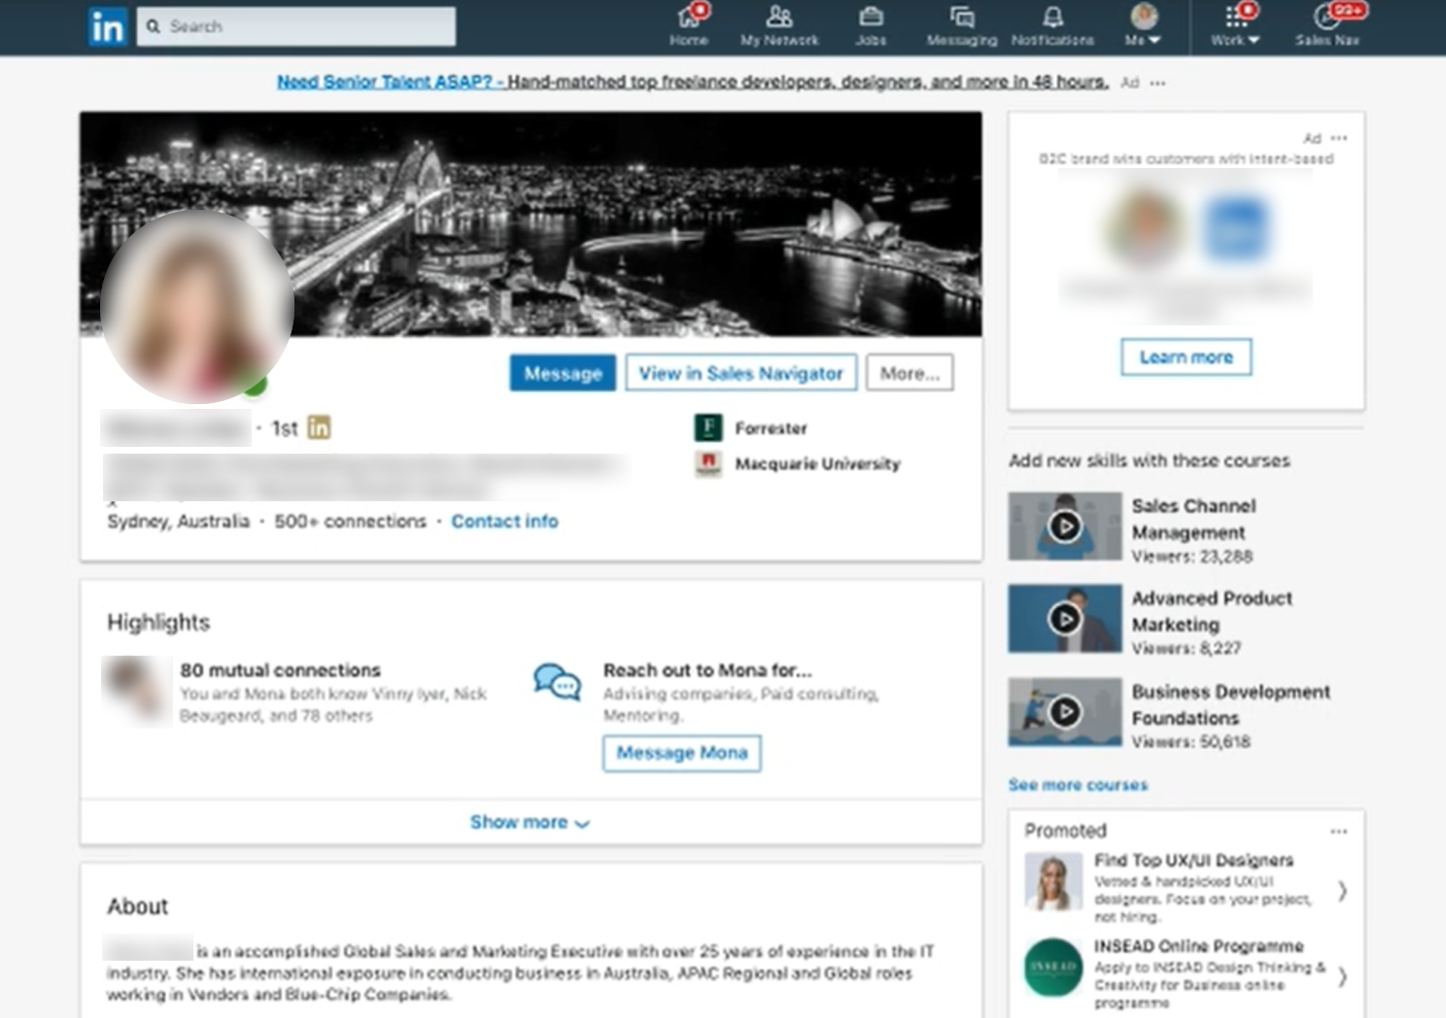

- Once you’ve found someone who meets your needs, open up a google sheet and start populating a database of potential collaborators to approach. Columns like Name, Business, Industry, LinkedIn profile link, are a great start.
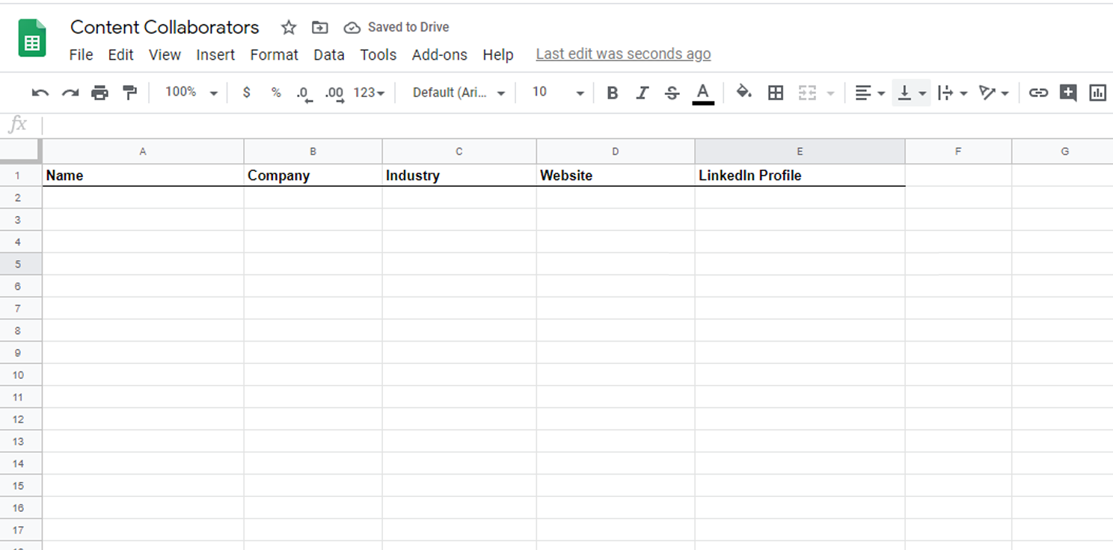

- Now it’s time to get in touch! Think about what you have to offer these people – you could offer to do the legwork when it comes to creating content, or you might have an engaged audience they would like access to. It’s good to already have some ideas in mind before you reach out; make it easy for them to just say ‘yes’ rather than leaving them with lots of work to do.
- Formulate a quick message introducing yourself and your content idea, and asking if they’d like to collaborate. It only has to be a few sentences long – don’t tell your life story, give them just enough info so that they know you’re credible.
- Send your message via LinkedIn messaging, or via email if you’re able to get their address. Mark on your spreadsheet who replies and who doesn’t so you can track responses and send reminder messages.

