How to write an engaging email subject line

Subject line
Your subject line is perhaps the most important piece of copy in the whole email. If it’s not compelling, your reader isn’t going to even open the email - and everything else you’ve written will go to waste. So it makes sense to spend a bit of time getting this right.

It’s always good to have multiple subject lines to test and choose from. One tip is to write one or two before you start writing the body of the email, then a couple more while you’re putting it together, and a couple more once the body is finished. Then go over them with someone else if possible.

Good subject lines:
- Are eye-catching
- Can be mysterious
- Don’t need to carry all the information
- Can be open-ended
- Spark curiosity

So, instead of something like:
“Read our new ebook about business insurance post-COVID-19”

Consider:
“Are you protected against COVID-19?“

Instead of:
“Would you be interested in attending our event?”

Consider:
“I’m sorry [Name], I forgot to include you!”

Instead of:
“Book in for our webinar today”

Consider:
“Secure your seat at the table with these industry experts”

Preheader text
The preheader text is the ‘preview’ copy that appears after the subject line, giving you a preview of what’s in the body of the email. If you don’t supply any, it will just pull text from the body of the email - but you should customise this to compel the reader to open the email. Note that this looks different on a phone than a laptop, and different again on Gmail compared to Outlook, for example.

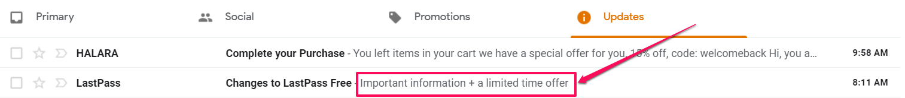

Your preheader text is just as important as your subject line copy. The two should work hand-in-hand - the subject line sparking curiosity, and the preheader text revealing a little more about what’s inside. You can use the ‘hook’ of the email in your preheader text to show the value you’ll bring them if they click.

Good preheader text:
- Shows a little more about what you’re delivering
- Considers how it will be shown on different devices
- Works in partnership with the subject line
- Uses specific details, like numbers and dates

So, instead of something like:
“Hi John, in the current landscape it’s important to...”

Consider:
“PLUS exclusive insights on how to protect your business”
“The five things you NEED to know”
“It’s all happening on July 12th and work won’t be the same”

